***Systems modelling predicts chronic inflammation and genomic instability prevent effective mitochondrial regulation during biological ageing.***

Alvaro Martinez Guimera1, Juel Rasmussen2, Daryl Shanley1

1. Institute for Cell and Molecular Biosciences (ICaMB), Ageing Research Laboratories, Campus for Ageing and Vitality, Newcastle University, United Kingdom

2. Faculty of Health and Medical Sciences, University of Copenhagen, Copenhagen, Denmark

The regulation of mitochondrial turnover under conditions of stress occurs partly through the AMPK-NAD-PGC1a-SIRT1 signalling pathway. This pathway can be affected by both genomic instability and chronic inflammation since both of these will result in an increased rate of NAD degradation through PARP1 and CD38 respectively. In this work we develop a computational model of this signalling pathway, calibrating it with- and validating it against- experimental data. The computational model is used to understand how the induction of increased mitochondrial turnover under conditions of stress may be affected by the molecular changes promoted by genomic instability, chronic inflammation and biological ageing in general. We report that the AMPK-NAD-PGC1a-SIRT1 signalling pathway becomes blunted with age and that this can prime for the accumulation of dysfunctional mitochondria. We argue that this is part of a ‘molecular habituation’ phenomenon that occurs during biological ageing where constitutive signals arising from damage accumulation drive an average reduction in network sensitivity and information transmission, as well as an increase in noise, across the cell.

**Introduction**

Genomic instability and mitochondrial dysfunction are two robust hallmarks of biological ageing (Lopez-Otin et al., 2013, Fakouri et al., 2019). Both of these can influence, prime, constrain and depend on each other as they co-evolve during the ageing process (Fakouri et al., 2019). DNA repair is a key process that determines the extent of genomic instability that develops with age. One of the substrates needed for effective DNA repair is NAD+. The reason for this is because NAD+ is a substrate in poly-ADP ribosylation (PARylation) reactions. These are mediated by PARP enzymes and are chemical modifications needed for resolving all types of DNA lesions (Wei and Yu, 2016, Fang et al., 2017). However, NAD+ is also needed in energy metabolism and energy sensing (Canto et al., 2015). In fact, NAD+ is part of a mito-nuclear signalling axis linking genomic stability with mitochondrial turnover and the energetic state of the cell (Canto et al., 2015).

The main molecular players in this pathway are AMPK, PGC1α, NAD, SIRT1 and PARP1. Previous work on the interplay between DNA damage and mitochondrial function has found antagonistic effects between PARP1 activity responding to DNA damage levels and mitochondrial turnover responding to deacetylated PGC1a levels (Canto et al., 2015). This suggests that the regulatory circuit mediates dynamic trade-offs between DNA repair activity and other cellular functions.

Further to genomic instability and mitochondrial function being key drivers of the ageing process, the importance of mitonuclear communication is suggested by studies where NAD+ supplementation has robustly increased both lifespan and healthspan in a variety of organisms(Belenky et al., 2007, Balan et al., 2008, Mouchiroud et al., 2013, Cerutti et al., 2014, Fang et al., 2016, Guan et al., 2017, Yaku et al., 2018). Conversely, low NAD+ levels have been associated with ageing pathology and mitochondrial dysfunction (Gomes et al., 2013, Zhu et al., 2015, Zhang et al., 2016). Interestingly, a mito-nuclear communication loop mediated by p21 and ROS has also been established to be a driver of cellular senescence (Passos et al., 2010). All of this suggests a key role of mito-nuclear communication in maintaining a balance between nuclear and mitochondrial maintenance with age (Fakouri et al., 2019).

Changes in the NAD+ -mediated mito-nuclear communication axis have been reported with age (Mendelsohn and Larrick, 2017). Sirtuin activity, NAD levels and AMPK responsiveness tend to decrease with age (Yaku et al., 2018, Camacho-Pereira et al., 2016, Salminen et al., 2016, Mendelsohn and Larrick, 2017) whilst DNA damage tends to increase with age (Freitas and de Magalhaes, 2011).

It is of interest to investigate how the ageing hallmarks of genomic instability and mitochondrial dysfunction may be linked through changes in mito-nuclear communication. In this work we employ a systems modelling approach to explore how age-related alterations may affect the functionality of the NAD+-mediated mito-nuclear communication axis.

**Results**

**Model development**

A computational model of the AMPK-PGC1α-NAD-SIRT1 axis was developed in COPASI (Hoops et al., 2006). This model is based on coupled ordinary differential equations (ODEs) that simulate changes in molecule abundances over time. The time units of the model correspond to hours and the molecule and volume units of the model correspond to arbitrary units (AU).

The development of the model starts with the identification of a core set of interactions within the pathway (illustrated in Figure 1). In this core network, AMPK is upstream of PGC1α. Upon AMPK activation via phosphorylation, there is a rapid PGC1α phosphorylation and a slow PGC1α deacetylation through an increase in NAD levels.

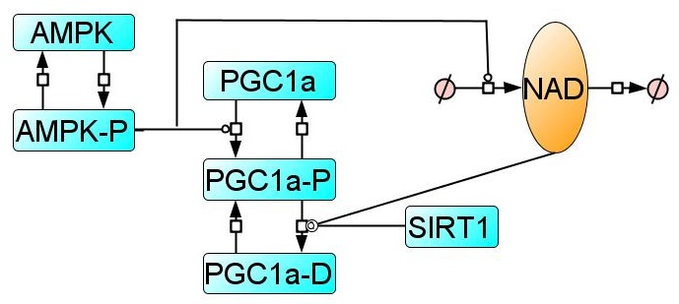***Figure 1.*** *Network structure delineating the core interactions of the AMPK-PGC1α-NAD-SIRT1 signalling pathway.* *‘-P’ suffix denotes a phosphorylated state and ‘-D’ suffix denotes a deacetylated state. The crossed circle denotes an empty state where an entity can be synthesised from or degraded to.*

Not all of the interactions within the core network illustrated in Figure 1 are of the same nature. Interactions denoting (de)phosphorylation and (de)acetylation reactions are mechanistic, since they represent well-defined physicochemical processes. However, the interaction that denotes the increase in NAD levels caused by an increased AMPK activity is phenomenological. That is, it models an underlying process which is more complex than represented in the model. This is since such transition will actually encode many underlying processes such as transcription factor activation, binding to a promoter, mRNA transcription and translation…

Because it is of interest to explore the behaviour of the signalling pathway in response to relevant conditions, the development of the model required the expansion of the core network structure illustrated in Figure 1 to that displayed in Figure 2. The full model expands on the core structure in Figure 1 by firstly introducing the treatment inputs into the network. Of note, the effect of a stimulus is modelled to occur separately to basal rates. For example, NAD degradation is partitioned into PARP1-dependent and PARP1-independent reactions. NAD synthesis is partitioned into AMPK-P – dependent and AMPK-P independent reactions. AMPK dephosphorylation is partitioned into glucose-dependent and glucose-independent reactions. And so on. In addition, instead of using simple transitions to attempt to model phenomenological interactions, ‘Delay’ variables are introduced. This is in order to faithfully capture the non-linearity and timescale of phenomenological interactions that are, in reality, more biologically complex than are represented here. A ‘NegReg’ dummy variable is used as a limiter of how much NAD+ may accumulate in the cell (since it is not practical to model the metabolism behind flux shifts that might 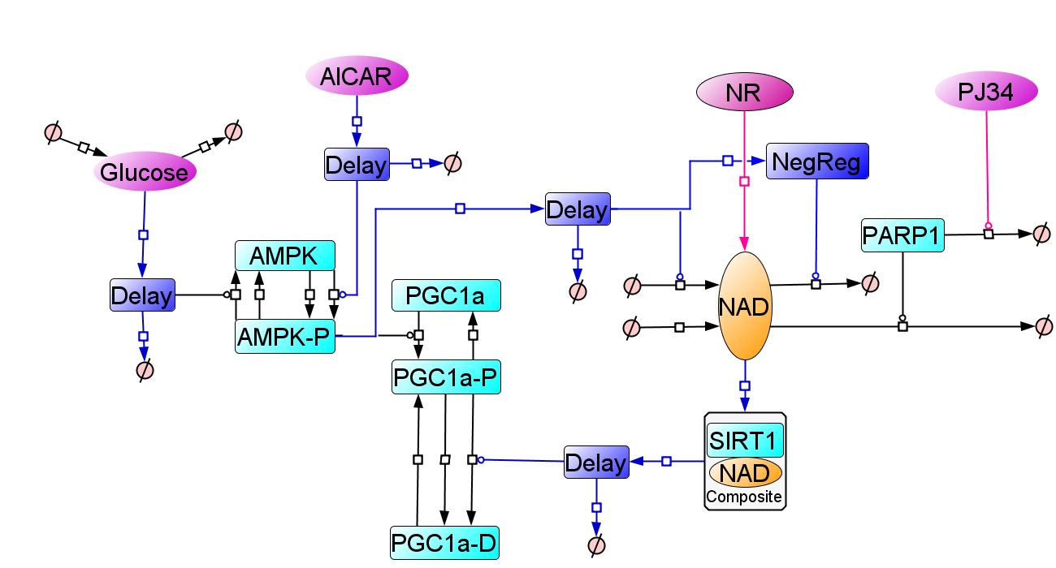promote an increased conversion of NAD+ into NADH or other species).

***Figure 2.*** *Model structure of the AMPK- PGC1α-SIRT1-NAD regulatory circuit. ‘-P’ suffix denotes a phosphorylated state and ‘-D’ suffix denotes a deacetylated state. The crossed circle denotes an empty state where an entity can be synthesised from or degraded to. Phenomenological transitions involving “Dummy” variables are shown in dark blue. Phenomenological transitions not involving delay variables are shown in pink. Modelled stimuli (network inputs) are shown in pink. Endogenous biological proteins are shown in light blue with their mechanistic interactions (reactions) shown in black. Note that ‘composite’ refers to a model species that is the product of two abundances (SIRT1 and NAD) so that the rate of the transition can occur non-linearly through a hill function but still respond to changes in the levels of two species (a hill function can only respond to one species by design).*

Although the model structure is informed by -and devised to approximate- current biological knowledge, the transition kinetics that determine the dynamics of the model structure are based on parameters whose values are largely unknown. However, these can be approximated through the use of parameter estimation procedures. The calibration of the model with experimental data is done through the use of a parameter estimation procedure which explores numerous combinations of potential parameter values to select those which result in the closest fit of the model simulation to the experimental data. Note that for all network inputs, experimental data from C2C12 myotubes was used for the calibration. See supplementary Figures S1 to S5 for the fits of the model to the calibration data.

To start probing the correspondence of the model with reality, it is necessary to retrospectively test its predictions. This is done by exposing the model to a body experimental data that has not been used in the model calibration processes. The fit between the model simulation and the experimental data will no longer be used to estimate model parameters. It will now be used as an evaluation of how accurately the calibrated model captures the underlying biology. The model validation exercise has involved 22 datasets extracted from 15 peer-reviewed publications (see supplementary Figures S6 to S24). The validations performed indicate that for most network inputs the model results in a good qualitative and quantitative accordance with the experimental data. Indeed, it can be said that the model is, to some degree, an approximation of the underlying biological system of interest. A summary of the depth and breadth of model validation can be seen in supplementary tables 1 and 2. The equations and parameters modelling the AMPK- PGC1α-SIRT1-NAD regulatory circuit can be found in supplementary tables 3-6.

**Increased PARP1 activity blunts the responsiveness of the** **AMPK-NAD-PGC1a-SIRT1 pathway.**

To investigate how an energetic stress signal would activate the pathway under conditions of genomic instability, the latter was simulated in the model as a 2.5 fold increase in basal PARP1 activity. The simulation of a 0.5mM AICAR (5-aminoimidazole-4-carboxamide ribonucleotide) treatment was used a proxy for a stress signal. This signal was introduced into the simulation after the system had equilibrated into a new steady state as a result of the increased genomic instability. As shown in Figure 3, under conditions of genomic instability the activation of the AMPK-NAD-PGC1a-SIRT1 pathway was blunted. The extent of pathway activation as reflected by the absolute levels reached by both NAD and deacetylated PGC1a was reduced. As expected, this pathway blunting occurred at the level of NAD since the upstream activation of AMPK remained unaffected (lines are superimposed in the time course for this species).

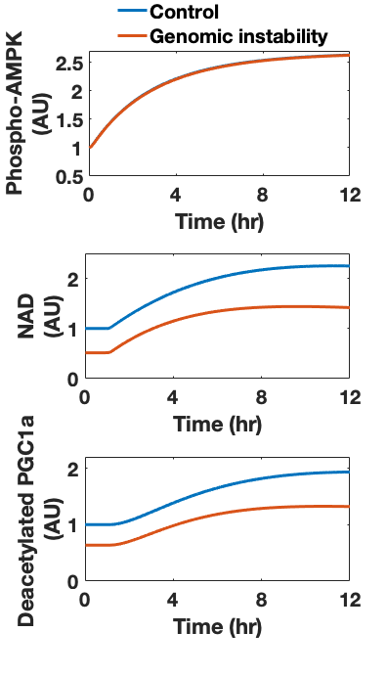

***Figure 3.*** *Simulated time courses of the AMPK-NAD-PGC1a-SIRT1 pathway in response to 0.5mM AICAR treatment under the presence or absence of genomic instability. Note that genomic instability refers to a 2.5 fold increase in PARP1 activity and Phospho-AMPK refers to the PhosphoThr172 – AMPK species.*

**Increased NAD degradation limits the accumulation of the NAD signal.**

The fact that increased NAD degradation dampens the activation of the signalling pathway is also indicated by the ability of different treatments to rescue the pathway activation under conditions of genomic instability. Model simulations in Figure 4 show that the preconditioning of cells with 0.5mM NR for 24 hrs does not provide a rescue of the pathway activation by 0.5mM AICAR as effective as preconditioning of cells with 1µM PJ34.

This is because the NR supplementation does not target the source of the system dampening: that is an increase in NAD turnover as a result of high PARP1 activity, whilst PJ34 works through the inhibition of PARP1. Model simulations were confirmed by experimental measurements in MEF cells (Figure 5) where genomic instability was introduced though the knockout of Rev1 resulting in a ~3 fold increase in PARP1 levels (supplementary Figure 25).

Note that this data does not mean that NR supplementation can never be as effective as a PJ34 treatment. A high enough NR supplementation could overwhelm the increased PARP1 activity and activate the pathway by acting as the activation signal itself. Supplementary Figure 26 confirms model simulations (supplementary Figure 27) that show changes in AMPK activation caused by AICAR treatment are not affected by any condition.

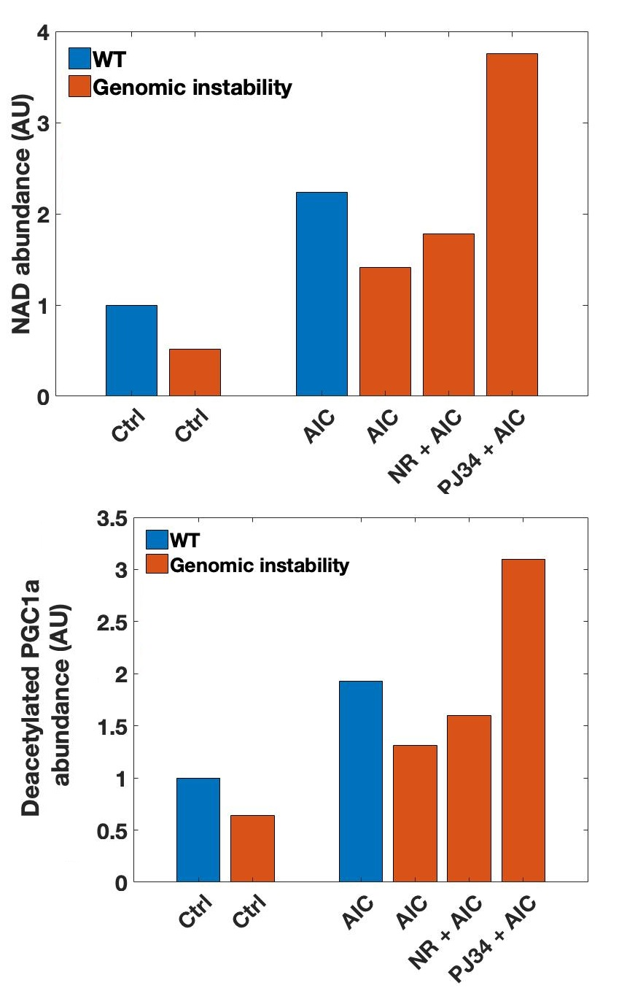

***Figure 4.*** *Model simulation of changes in NAD and deacetylated PGC1α levels as a result of AICAR treatments. AIC=0.5mM AICAR treatment. NR= preconditioning of cells with 0.5mM Nicotinamide Riboside for 24hrs. PJ34 = preconditioning of cells with 1µM PJ34 treatment for 24hrs. The timepoint for AICAR measurement is 12hrs post-treatment initiation. ‘Genomic instability’ refers to an increase in basal PARP1 activity of 2.5 fold. Ctrl = Control (no AICAR treatment). WT = wildtype.*

***Figure 5.*** *Measured changes in NAD and deacetylated PGC1α levels as a result of AICAR treatments in Rev1 -/- cells. AIC=0.5mM AICAR treatment. NR= preconditioning of cells with 0.5mM Nicotinamide Riboside for 24hrs. PJ34 = preconditioning of cells with 1µM PJ34 treatment for 24hrs. The timepoint for AICAR measurement is 12hrs post-treatment initiation. Ctrl = Control (no AICAR treatment). WT = wildtype MEF. Error bars correspond to SEM. *=p<0.05.*

**This effect is unlikely to be unique to genomic instability.**

That an increase in the degradation rate of a “reservoir-molecule” such as NAD will dampen any subsequent attempts to increase its levels through a given signalling-induced flux of the same molecule is likely to be a general phenomenon. Figure 6 shows a simple system of a signalling trigger with flux (*k3*) acting on a molecule with synthesis (*k1*) and degradation/use (*k2*). A signalling event that introduces a given flux of a signalling molecule will result in a smaller change in the overall levels of the “reservoir-molecule” under higher turnover conditions (Figure 6b where blue shows low NAD levels and yellow high).

Furthermore, for a given turnover rate of the “reservoir-molecule”, an increase in the degradation rate will result in the dampening of the signal regardless of the magnitude of the signalling flux being introduced (Figure 6c). It can be seen that in this case a decrease in the synthesis rate of NAD (*k1*) is not equivalent to an increase in its degradation rate (*k2*), since the synthesis rate does not affect the accumulation limit of the signal being introduced (Figure 6c). Hence, any age-related mechanism that results in an increase in the rate of NAD degradation, be it through increased PARP1 or CD38 activity, will have the same dampening effect on the AMPK-NAD-PGC1a-SIRT1 pathway. This means that both genomic instability and chronic inflammation can interfere with the functionality of this pathway during the ageing process.

As an analogy, imagine a fax machine attached to a shredder. The shredder cannot be faster than the fax machine in order for any message to get through. However, the faster the shredder, the less time the message (aka. the signal) will be available. If both the fax machine and the shredder increase their speeds but maintain the same speed-ratio to each other, it would be more difficult to discern any message appearing on the rapidly flowing paper. The message would have to be printed bigger (aka. the signal should be stronger) to maintain a level of discernment. In this sense, a higher turnover confers the system a greater robustness to perturbations.

This perspective sheds some light on how nuclear maintenance may be prioritised over mitochondrial maintenance. An energetic stress signal activates the AMPK-NAD-PGC1α-SIRT1 pathway by increasing SIRT1 activity through the increase in NAD levels but not SIRT1 levels (Canto et al., 2009) – meaning that the reaction is substrate-limited – and so will also increase the substrate for PARP1-mediated reactions. This being whilst a genomic stress signal in the form of increased PARP1 activity will reduce available NAD for SIRT1-mediated reactions. Thus, the prioritisation lies in the asymmetrical influence on the parameters controlling the NAD “reservoir-molecule” as shown in Figure 6. One signal (energetic stress) will influence NAD synthesis and the other (genomic stress) will influence NAD utilisation. Under conditions of conflicting signals where both genomic and energetic stress may be present in an aged cell, genomic maintenance would be prioritised. Note that this mechanism of prioritisation can act in concert to other interactions between PARP1 and SIRT1 (Canto et al., 2015).

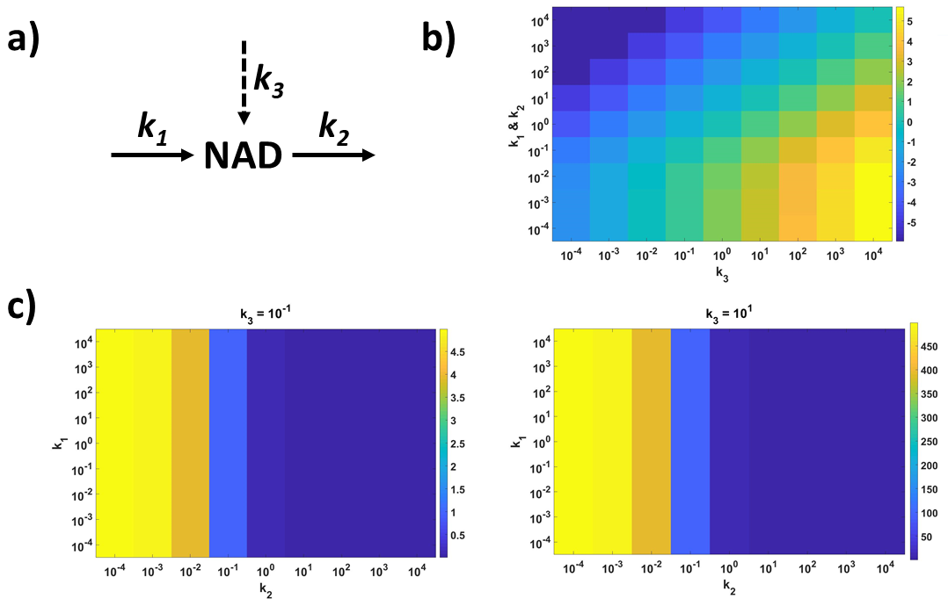  
***Figure 6.*** *Peak activation magnitudes of a “reservoir-molecule” under different turnover conditions.* ***a)*** *Model diagram. k1 = synthesis rate, k2 = utilisation rate, k3* = signalling flux. ***b)*** *Peak activation magnitude (log-transformed) by signalling flux* *k3 at different turnover rates (where k1=k2).* ***c)*** *Peak activation magnitude for two different k3 signalling flux values at different combinations of synthesis and utilisation rates (k1 and k2).*

**Reduced pathway activation promotes the accumulation of dysfunctional mitochondria.**

What would be the functional consequence of a dampened AMPK-NAD-PGC1a-SIRT1 signalling pathway? Considering that mitophagy can be triggered through this pathway under conditions of stress (Herzig and Shaw, 2018, Rabinovitch et al., 2017, Zhang et al., 2018) it is feasible that a pathway dampening due to a higher rate of NAD utilisation would lead to a reduced ability to maintain healthy mitochondrial populations through this signalling axis. This would be expected to result in an increased rate of accumulation of dysfunctional mitochondria.

This can be shown in principle by coupling the validated model of the AMPK-NAD-PGC1a-SIRT1 signalling axis to a simple model of mitochondrial populations (see Figure 7 below). In such a model, newly formed (healthy) mitochondria can become damaged/old at a given rate. The latter can then trigger AMPK activation through an increased AMP/ATP ratio in order to enhance mitophagy and remove the excess old mitochondria. Upon pathway activation, deacetylated PGC1α induces mitophagy and thus the disappearance of both types of mitochondrial populations at different rates (in the scale of those reported by [Dalle Pezze et al. (2014)](#_ENREF_12" \o "Dalle Pezze, 2014 #53)). To model the age-dependent accumulation of dysfunctional mitochondria, we introduce a positive feedback loop where mitochondrial dysfunction can prime for more mitochondrial dysfunction.

The simulation of this positive feedback loop results in a given rate of damaged/old mitochondrial accumulation when simulated over 80 years as shown in Figure 8. Note that the simulation of the mitochondrial module alone involves assuming a fixed value of 1 a.u of deacetylated PGC1α where old/damaged mitochondria are not coupled to AMPK activation. See equations and parameter values for the mitochondrial module in supplementary tables 7-10.

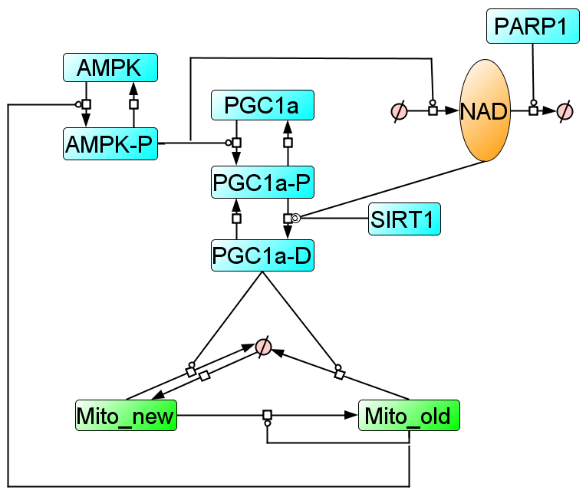***Figure 7.*** *Coupling of the AMPK-NAD-PGC1a-SIRT1 model (shown in simplified form in blue) with a simple model of mitochondria populations (green). Dashed circle denotes a an ‘empty’ state where molecules can be synthesised from or utilised/degraded to.*

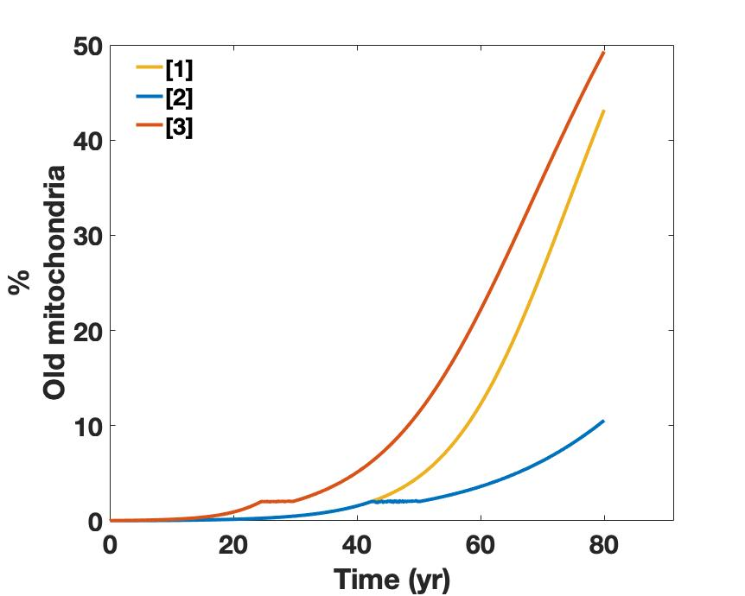***Figure 8.*** *Accumulation of dysfunctional mitochondria over 80 years simulated by [1] mitochondrial module alone; [2] mitochondrial module coupled to the AMPK-NAD-PGC1α-SIRT1 signalling axis with a fixed PARP1 level of 1 a.u;*

*[3] mitochondrial module coupled to the AMPK-NAD-PGC1α-SIRT1 signalling axis with a fixed PARP1 level of 2.5 a.u.*  
Figure 8 shows how the coupling of the mitochondrial module to the AMPK-NAD-PGC1α-SIRT1 axis with a PARP1 value fixed to 1 a.u results in a substantially reduced accumulation of dysfunctional mitochondria over 80 years (Figure 8 curve 1 vs curve 2). This is since the stress conditions associated with the accumulation of dysfunctional mitochondria can now result in increased mitophagy through the activation of the AMPK-NAD-PGC1α-SIRT1 pathway. However, when PARP1 value was fixed to 2.5, the accumulation of dysfunctional mitochondria is even faster than if the mitochondria were not able to be regulated (Figure 8 curve 3 vs curve 1). This is because the high PARP1 activity lowered basal deacetylated PGC1α levels below the value of 1 a.u which is assumed in the simulations involving the mitochondrial module alone. Such simulations would suggest that increased NAD degradation with age, caused by genomic instability, chronic inflammation or both, would interfere with the ability of mitochondria to regulated. This is especially since the AMPK-NAD-PGC1α-SIRT1 pathway also controls FOXO-induced mitophagy through the same mechanism (Canto et al., 2009) and so the pathway dampening would affect mitophagy induction through two main regulatory transcription factors: FOXO and PGC1α.

To make the simulations more realistic, the positive feedback loop driving a given rate of dysfunctional mitochondria accumulation over 80 years can be coupled to PARP1 so that the levels of this molecule gradually increase over the years instead of remaining fixed at a given value. Modelling such age-related changes to PARP1 levels still shows the same effect as that shown in Figure 8 (supplementary Figure 28). Perhaps unsurprisingly, simulating an age-related decrease in SIRT1 levels (supplementary Figure 29) and AMPK levels (supplementary Figure 30) in a similar manner also results in an increased accumulation of dysfunctional mitochondria due to the reduced ability of the latter to activate the AMPK-NAD-PGC1α-SIRT1 signalling pathway to induce mitophagy. Interestingly, an age-related increase in AMPK dephosphorylation simulated by an age-related hyperglycaemia does not result in any changes to the accumulation of dysfunctional mitochondria since the constant stress signal causing an increased AMPK phosphorylation would balance the increased dephosphorylation (supplementary Figure 31).

In accordance with the established beneficial effects of life-long NAD supplementation, the simulation of this intervention by fixing NR to a value of 100 a.u (to model a life-long supplementation with 0.1mM Nicotinamide Riboside at the cellular level) leads to a marked reduction in the accumulation of dysfunctional mitochondria over 80 years (supplementary Figure 32).

**Discussion**

NAD is a molecule involved in a myriad of biological processes (Fakouri et al., 2019). Its relevance to the ageing process is highlighted by a multitude of studies that report the modulation of organism lifespan and healthspan through changes in basal NAD levels (Belenky et al., 2007, Balan et al., 2008, Mouchiroud et al., 2013, Cerutti et al., 2014, Guan et al., 2017). The lowering of basal NAD levels with age has been associated with mitochondrial dysfunction (Camacho-Pereira et al., 2016). In this work we demonstrate how the latter can be promoted by an increased turnover of NAD in addition to its absolute levels *per se*. Whilst low NAD levels can be a source of metabolic stress, a high NAD turnover can prevent an adaptation to this stress through increased mitophagy. Interestingly, Dalle Pezze et al. (2014) reported a similar effect where pharmacological interventions aimed at reversing the senescent state of human fibroblast cells were less effective due to a higher mitochondrial turnover.

This is not the only mechanism that can render a regulatory system less sensitive to signalling. We also demonstrate that reported changes to the AMPK-NAD-PGC1a-SIRT1 pathway such as decreased AMPK levels and SIRT1 levels would also result in a loss of pathway sensitivity. The computational model did not imply this for an age-related increase in AMPK dephosphorylation. This is because the model predicts the stress signal that tries to activate AMPK becomes constitutively present and thus balances out an increase in the dephosphorylation of this molecule. However, this assumes that AMPK’s ability to sense AMP/ADP and be subsequently phosphorylated remains unchanged with age. This assumption may not always hold true (Hardman et al., 2014).

It thus seems that the AMPK-NAD-PGC1a-SIRT1 pathway can be blunted through various different mechanisms during biological ageing. This observation is not unique to this regulatory circuit, as can be exemplified by mTOR signalling (Francaux et al., 2016, Carroll et al., 2017), Nrf2 (Zhang et al., 2015) and redox signalling in general (Vasilaki et al., 2006, McDonagh et al., 2014, Cobley et al., 2019) , p38 signalling (Xiao and Majumdar, 2000, Suh and Park, 2001), HSF1 activation (Lu et al., 2000, Heydari et al., 2000) and others (Conconi et al., 1996, Carlson et al., 2008, Haak et al., 2009, Bakondi et al., 2011, Dues et al., 2016) .

**Conclusion**

The increased NAD degradation reported with age is predicted to lead to a dampening of the activation of the AMPK-NAD-PGC1α-SIRT1 signalling pathway. Consequently, mitophagy is less able to be induced under conditions of stress and so dysfunctional mitochondria accumulate. Both genomic instability and chronic inflammation result in an increase in NAD degradation and can be viewed as age-related constitutive signals that interefere with mito-nuclear communication. The nature of this age-related dysregulation can be regarded as a ‘molecular habituation’ phenomenon in the cell’s molecular network. This involves stochastic damage resulting in homeostatic dysregulations which manifest as constitutive signals that percolate through the molecular interaction network stabilising an average state of increased noise, reduced sensitivity and reduced information flow.

**Methods**

Computational

Model simulation: A computational model of the AMPK-PGC1α-NAD-SIRT1 axis was developed in COPASI (Hoops et al., 2006). This model is based on coupled ordinary differential equations (ODEs) that simulate changes in species’ abundances over time. The model is simulated deterministically using the LSODA algorithm with values of ‘*Relative Tolerance*’ and ‘*Absolute Tolerance*’ of *1e-6* and *1e-12* respectively for a ‘*Max internal steps*’ of *10000*.

**Simulation of AICAR treatment.** The simulation of a 0.5mM AICAR treatment involves setting the initial abundance ‘AICAR’ variable in the model from 0 to 1. A unit increase in the value of this variable corresponds to a 0.5mM increase in the dose of the AICAR treatment being simulated. Thus, the simulation of a 2mM AICAR treatment corresponds to a setting of this variable to a value of 4.

**Simulation of NR supplementation.** The simulation of NR supplementation in the model involves setting the initial abundance of the NR-NMN variable from 0 to X where X is the NR concentration in µM that aims to be simulated. Hence, the simulation of a 500µM NR supplementation involves setting this variable to a value of 500.

**Simulation of glucose restriction.** The simulation of glucose restriction involves changing the value of the glucose influx rate constant *k26* to the desired value of a glucose steady state in mM. For example, the simulation of a glucose restriction protocol from 25mM to 5mM glucose involves changing the value of *k26* from 25 to 5 (or vice-versa for the simulation of a glucose addition protocol). Note that the default value of the latter parameter is 25 since the standard cell culture protocol of C2C12 myotubes, from which most data is utilised in the development of the model, involves 25mM glucose.

**Simulation of a PJ34 treatment.** The simulation of PARP1 inhibition through PJ34 is modelled by setting the initial abundance of the ‘PARP1’ variable from 1 to 0.

**Simulation of genomic instability.** The simulation of genomic instability feeding through increased PARP1 activity is modelled by changing the initial abundance of the ‘PARP1’ level to the fold-change measured experimentally. This means that if an experimental model of genomic instability displays a 3-fold increase in PARP1 activity over controls, the initial abundance of the ‘PARP1’ variable should be changed from 1 to 3 in the model. The model must be then allowed to equilibrate to the new steady state stabilised by the new level of genomic instability. Any treatments simulated under conditions of genomic instability must thus be simulated as an ‘Event’ that occurs after model equilibration to the new levels of genomic instability.

**Simulation of SIRT1 knockout.** The simulation of SIRT1 knockout involves reducing the initial abundance of the ‘SIRT1’ variable to by the estimated or measured percentage reduction in SIRT1 levels. Thus is a SIRT1 knockout systems displays 1/10th of the SIRT1 levels in controls, the value of the ‘SIRT1’ variable in the model should be altered from 1 to 0.1.

Parameter estimation: The parameter estimation procedure was carried out using a ‘global-chaser’ strategy in COPASI (Welsh et al., 2018). The initial round of parameter estimation involved the use of the ‘*Particle Swarm*’ algorithm with an ‘*Iteration Limit*’ setting of *4000* and a ‘*Swarm size*’ of *100* (with ‘*Std. Deviation*’ left at standard setting of *1e-6*). The ‘*Progress of Fit*’ plot in the ‘*Output assistant*’ was activated in order to visually confirm the minimization of the objective function to a stable minimum. If a stable minimum was not achieved then the algorithm ‘*Iteration Limit*’ was increased. Once this requisite was satisfied the model parameters were updated with the estimated ones. The second round of parameter estimation involved the use of the ‘Hooke&Jeeves’ algorithm under standard settings.

**References**

BAKONDI, E., CATALGOL, B., BAK, I., JUNG, T., BOZAYKUT, P., BAYRAMICLI, M., OZER, N. K. & GRUNE, T. 2011. Age-related loss of stress-induced nuclear proteasome activation is due to low PARP-1 activity. *Free Radic Biol Med,* 50**,** 86-92.

BALAN, V., MILLER, G. S., KAPLUN, L., BALAN, K., CHONG, Z. Z., LI, F., KAPLUN, A., VANBERKUM, M. F., ARKING, R., FREEMAN, D. C., MAIESE, K. & TZIVION, G. 2008. Life span extension and neuronal cell protection by Drosophila nicotinamidase. *J Biol Chem,* 283**,** 27810-9.

BELENKY, P., RACETTE, F. G., BOGAN, K. L., MCCLURE, J. M., SMITH, J. S. & BRENNER, C. 2007. Nicotinamide riboside promotes Sir2 silencing and extends lifespan via Nrk and Urh1/Pnp1/Meu1 pathways to NAD+. *Cell,* 129**,** 473-84.

CAMACHO-PEREIRA, J., TARRAGO, M. G., CHINI, C. C. S., NIN, V., ESCANDE, C., WARNER, G. M., PURANIK, A. S., SCHOON, R. A., REID, J. M., GALINA, A. & CHINI, E. N. 2016. CD38 Dictates Age-Related NAD Decline and Mitochondrial Dysfunction through an SIRT3-Dependent Mechanism. *Cell Metab,* 23**,** 1127-1139.

CANTO, C., GERHART-HINES, Z., FEIGE, J. N., LAGOUGE, M., NORIEGA, L., MILNE, J. C., ELLIOTT, P. J., PUIGSERVER, P. & AUWERX, J. 2009. AMPK regulates energy expenditure by modulating NAD+ metabolism and SIRT1 activity. *Nature,* 458**,** 1056-60.

CANTO, C., MENZIES, K. J. & AUWERX, J. 2015. NAD(+) Metabolism and the Control of Energy Homeostasis: A Balancing Act between Mitochondria and the Nucleus. *Cell Metab,* 22**,** 31-53.

CARLSON, M. E., SILVA, H. S. & CONBOY, I. M. 2008. Aging of signal transduction pathways, and pathology. *Exp Cell Res,* 314**,** 1951-61.

CARROLL, B., NELSON, G., RABANAL-RUIZ, Y., KUCHERYAVENKO, O., DUNHILL-TURNER, N. A., CHESTERMAN, C. C., ZAHARI, Q., ZHANG, T., CONDUIT, S. E., MITCHELL, C. A., MADDOCKS, O. D. K., LOVAT, P., VON ZGLINICKI, T. & KOROLCHUK, V. I. 2017. Persistent mTORC1 signaling in cell senescence results from defects in amino acid and growth factor sensing. *J Cell Biol,* 216**,** 1949-1957.

CERUTTI, R., PIRINEN, E., LAMPERTI, C., MARCHET, S., SAUVE, A. A., LI, W., LEONI, V., SCHON, E. A., DANTZER, F., AUWERX, J., VISCOMI, C. & ZEVIANI, M. 2014. NAD(+)-dependent activation of Sirt1 corrects the phenotype in a mouse model of mitochondrial disease. *Cell Metab,* 19**,** 1042-9.

COBLEY, J. N., SAKELLARIOU, G. K., HUSI, H. & MCDONAGH, B. 2019. Proteomic strategies to unravel age-related redox signalling defects in skeletal muscle. *Free Radic Biol Med,* 132**,** 24-32.

CONCONI, M., SZWEDA, L. I., LEVINE, R. L., STADTMAN, E. R. & FRIGUET, B. 1996. Age-related decline of rat liver multicatalytic proteinase activity and protection from oxidative inactivation by heat-shock protein 90. *Arch Biochem Biophys,* 331**,** 232-40.

DALLE PEZZE, P., NELSON, G., OTTEN, E. G., KOROLCHUK, V. I., KIRKWOOD, T. B., VON ZGLINICKI, T. & SHANLEY, D. P. 2014. Dynamic modelling of pathways to cellular senescence reveals strategies for targeted interventions. *PLoS Comput Biol,* 10**,** e1003728.

DUES, D. J., ANDREWS, E. K., SCHAAR, C. E., BERGSMA, A. L., SENCHUK, M. M. & VAN RAAMSDONK, J. M. 2016. Aging causes decreased resistance to multiple stresses and a failure to activate specific stress response pathways. *Aging (Albany NY),* 8**,** 777-95.

FAKOURI, N. B., HOU, Y., DEMAREST, T. G., CHRISTIANSEN, L. S., OKUR, M. N., MOHANTY, J. G., CROTEAU, D. L. & BOHR, V. A. 2019. Toward understanding genomic instability, mitochondrial dysfunction and aging. *FEBS J,* 286**,** 1058-1073.

FANG, E. F., KASSAHUN, H., CROTEAU, D. L., SCHEIBYE-KNUDSEN, M., MAROSI, K., LU, H., SHAMANNA, R. A., KALYANASUNDARAM, S., BOLLINENI, R. C., WILSON, M. A., ISER, W. B., WOLLMAN, B. N., MOREVATI, M., LI, J., KERR, J. S., LU, Q., WALTZ, T. B., TIAN, J., SINCLAIR, D. A., MATTSON, M. P., NILSEN, H. & BOHR, V. A. 2016. NAD(+) Replenishment Improves Lifespan and Healthspan in Ataxia Telangiectasia Models via Mitophagy and DNA Repair. *Cell Metab,* 24**,** 566-581.

FANG, E. F., LAUTRUP, S., HOU, Y., DEMAREST, T. G., CROTEAU, D. L., MATTSON, M. P. & BOHR, V. A. 2017. NAD(+) in Aging: Molecular Mechanisms and Translational Implications. *Trends Mol Med,* 23**,** 899-916.

FRANCAUX, M., DEMEULDER, B., NASLAIN, D., FORTIN, R., LUTZ, O., CATY, G. & DELDICQUE, L. 2016. Aging Reduces the Activation of the mTORC1 Pathway after Resistance Exercise and Protein Intake in Human Skeletal Muscle: Potential Role of REDD1 and Impaired Anabolic Sensitivity. *Nutrients,* 8.

FREITAS, A. A. & DE MAGALHAES, J. P. 2011. A review and appraisal of the DNA damage theory of ageing. *Mutat Res,* 728**,** 12-22.

GOMES, A. P., PRICE, N. L., LING, A. J., MOSLEHI, J. J., MONTGOMERY, M. K., RAJMAN, L., WHITE, J. P., TEODORO, J. S., WRANN, C. D., HUBBARD, B. P., MERCKEN, E. M., PALMEIRA, C. M., DE CABO, R., ROLO, A. P., TURNER, N., BELL, E. L. & SINCLAIR, D. A. 2013. Declining NAD(+) induces a pseudohypoxic state disrupting nuclear-mitochondrial communication during aging. *Cell,* 155**,** 1624-38.

GUAN, Y., WANG, S. R., HUANG, X. Z., XIE, Q. H., XU, Y. Y., SHANG, D. & HAO, C. M. 2017. Nicotinamide Mononucleotide, an NAD(+) Precursor, Rescues Age-Associated Susceptibility to AKI in a Sirtuin 1-Dependent Manner. *J Am Soc Nephrol,* 28**,** 2337-2352.

HAAK, J. L., BUETTNER, G. R., SPITZ, D. R. & KREGEL, K. C. 2009. Aging augments mitochondrial susceptibility to heat stress. *Am J Physiol Regul Integr Comp Physiol,* 296**,** R812-20.

HARDMAN, S. E., HALL, D. E., CABRERA, A. J., HANCOCK, C. R. & THOMSON, D. M. 2014. The effects of age and muscle contraction on AMPK activity and heterotrimer composition. *Exp Gerontol,* 55**,** 120-8.

HERZIG, S. & SHAW, R. J. 2018. AMPK: guardian of metabolism and mitochondrial homeostasis. *Nat Rev Mol Cell Biol,* 19**,** 121-135.

HEYDARI, A. R., YOU, S., TAKAHASHI, R., GUTSMANN-CONRAD, A., SARGE, K. D. & RICHARDSON, A. 2000. Age-related alterations in the activation of heat shock transcription factor 1 in rat hepatocytes. *Exp Cell Res,* 256**,** 83-93.

HOOPS, S., SAHLE, S., GAUGES, R., LEE, C., PAHLE, J., SIMUS, N., SINGHAL, M., XU, L., MENDES, P. & KUMMER, U. 2006. COPASI--a COmplex PAthway SImulator. *Bioinformatics,* 22**,** 3067-74.

LOPEZ-OTIN, C., BLASCO, M. A., PARTRIDGE, L., SERRANO, M. & KROEMER, G. 2013. The hallmarks of aging. *Cell,* 153**,** 1194-217.

LU, J., PARK, J. H., LIU, A. Y. & CHEN, K. Y. 2000. Activation of heat shock factor 1 by hyperosmotic or hypo-osmotic stress is drastically attenuated in normal human fibroblasts during senescence. *J Cell Physiol,* 184**,** 183-90.

MCDONAGH, B., SAKELLARIOU, G. K., SMITH, N. T., BROWNRIDGE, P. & JACKSON, M. J. 2014. Differential cysteine labeling and global label-free proteomics reveals an altered metabolic state in skeletal muscle aging. *J Proteome Res,* 13**,** 5008-21.

MENDELSOHN, A. R. & LARRICK, J. W. 2017. The NAD+/PARP1/SIRT1 Axis in Aging. *Rejuvenation Res,* 20**,** 244-247.

MOUCHIROUD, L., HOUTKOOPER, R. H., MOULLAN, N., KATSYUBA, E., RYU, D., CANTO, C., MOTTIS, A., JO, Y. S., VISWANATHAN, M., SCHOONJANS, K., GUARENTE, L. & AUWERX, J. 2013. The NAD(+)/Sirtuin Pathway Modulates Longevity through Activation of Mitochondrial UPR and FOXO Signaling. *Cell,* 154**,** 430-41.

PASSOS, J. F., NELSON, G., WANG, C., RICHTER, T., SIMILLION, C., PROCTOR, C. J., MIWA, S., OLIJSLAGERS, S., HALLINAN, J., WIPAT, A., SARETZKI, G., RUDOLPH, K. L., KIRKWOOD, T. B. & VON ZGLINICKI, T. 2010. Feedback between p21 and reactive oxygen production is necessary for cell senescence. *Mol Syst Biol,* 6**,** 347.

RABINOVITCH, R. C., SAMBORSKA, B., FAUBERT, B., MA, E. H., GRAVEL, S. P., ANDRZEJEWSKI, S., RAISSI, T. C., PAUSE, A., ST-PIERRE, J. & JONES, R. G. 2017. AMPK Maintains Cellular Metabolic Homeostasis through Regulation of Mitochondrial Reactive Oxygen Species. *Cell Rep,* 21**,** 1-9.

SALMINEN, A., KAARNIRANTA, K. & KAUPPINEN, A. 2016. Age-related changes in AMPK activation: Role for AMPK phosphatases and inhibitory phosphorylation by upstream signaling pathways. *Ageing Res Rev,* 28**,** 15-26.

SUH, Y. & PARK, S. C. 2001. Differential activation of mitogen-activated protein kinases by methyl methanesulfonate in the kidney of young and old rats. *Mutat Res,* 497**,** 11-8.

VASILAKI, A., MCARDLE, F., IWANEJKO, L. M. & MCARDLE, A. 2006. Adaptive responses of mouse skeletal muscle to contractile activity: The effect of age. *Mech Ageing Dev,* 127**,** 830-9.

WEI, H. & YU, X. 2016. Functions of PARylation in DNA Damage Repair Pathways. *Genomics Proteomics Bioinformatics,* 14**,** 131-139.

WELSH, C. M., FULLARD, N., PROCTOR, C. J., MARTINEZ-GUIMERA, A., ISFORT, R. J., BASCOM, C. C., TASSEFF, R., PRZYBORSKI, S. A. & SHANLEY, D. P. 2018. PyCoTools: a Python toolbox for COPASI. *Bioinformatics,* 34**,** 3702-3710.

XIAO, Z. Q. & MAJUMDAR, A. P. 2000. Induction of transcriptional activity of AP-1 and NF-kappaB in the gastric mucosa during aging. *Am J Physiol Gastrointest Liver Physiol,* 278**,** G855-65.

YAKU, K., OKABE, K. & NAKAGAWA, T. 2018. NAD metabolism: Implications in aging and longevity. *Ageing Res Rev,* 47**,** 1-17.

ZHANG, H., DAVIES, K. J. A. & FORMAN, H. J. 2015. Oxidative stress response and Nrf2 signaling in aging. *Free Radic Biol Med,* 88**,** 314-336.

ZHANG, H., LIU, B., LI, T., ZHU, Y., LUO, G., JIANG, Y., TANG, F., JIAN, Z. & XIAO, Y. 2018. AMPK activation serves a critical role in mitochondria quality control via modulating mitophagy in the heart under chronic hypoxia. *Int J Mol Med,* 41**,** 69-76.

ZHANG, H., RYU, D., WU, Y., GARIANI, K., WANG, X., LUAN, P., D'AMICO, D., ROPELLE, E. R., LUTOLF, M. P., AEBERSOLD, R., SCHOONJANS, K., MENZIES, K. J. & AUWERX, J. 2016. NAD(+) repletion improves mitochondrial and stem cell function and enhances life span in mice. *Science,* 352**,** 1436-43.

ZHU, X. H., LU, M., LEE, B. Y., UGURBIL, K. & CHEN, W. 2015. In vivo NAD assay reveals the intracellular NAD contents and redox state in healthy human brain and their age dependences. *Proc Natl Acad Sci U S A,* 112**,** 2876-81.